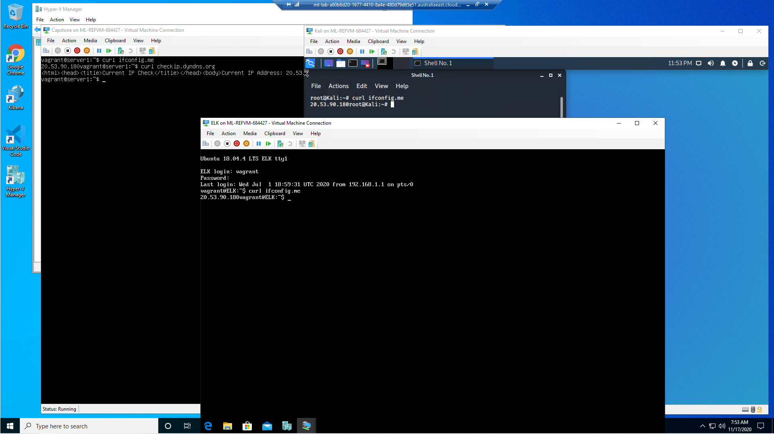

From within kali vm; ascertain network interfaces and associated IP addresses.

Command: $ curl ifconfig.me

Result: 192.168.1.90/24

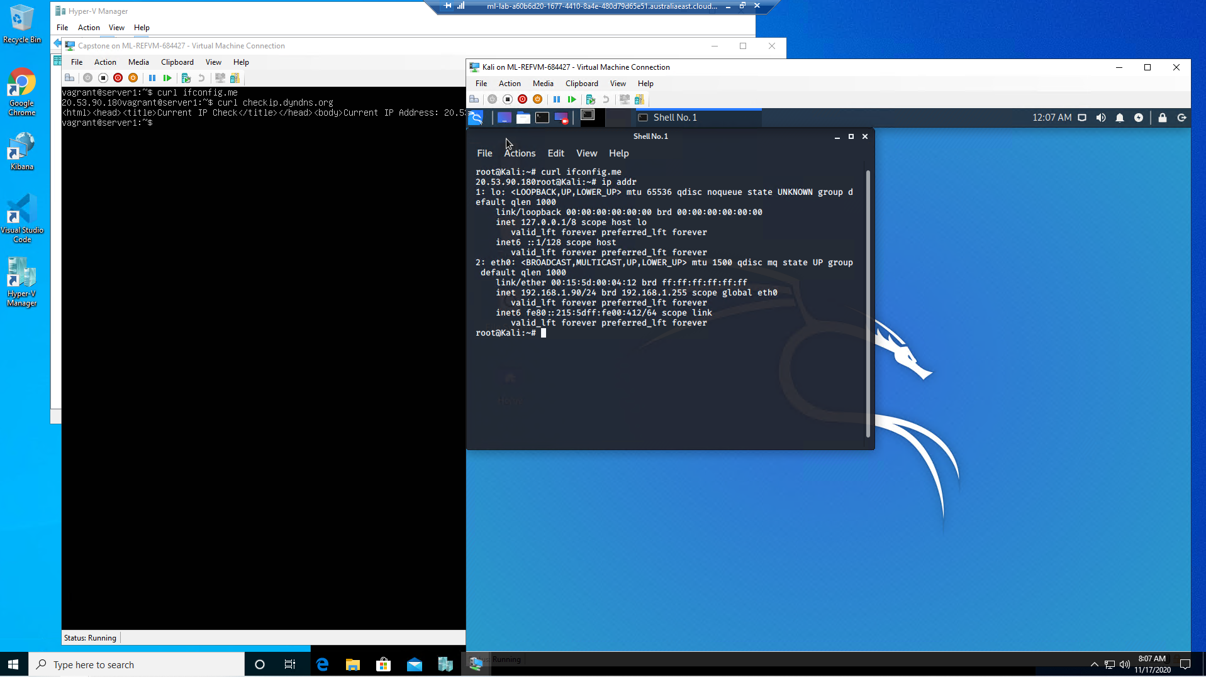

Command: $ nmap 192.168.1.90/24

Result: $ 256 IP addresses scanned, 4 hosts up

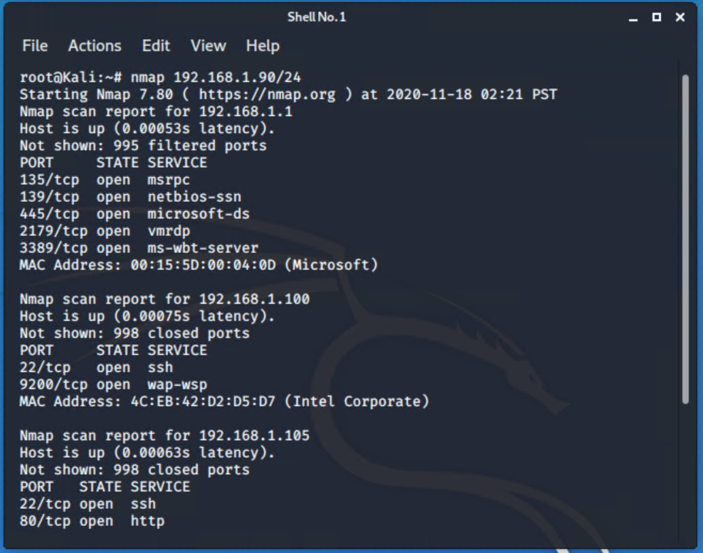

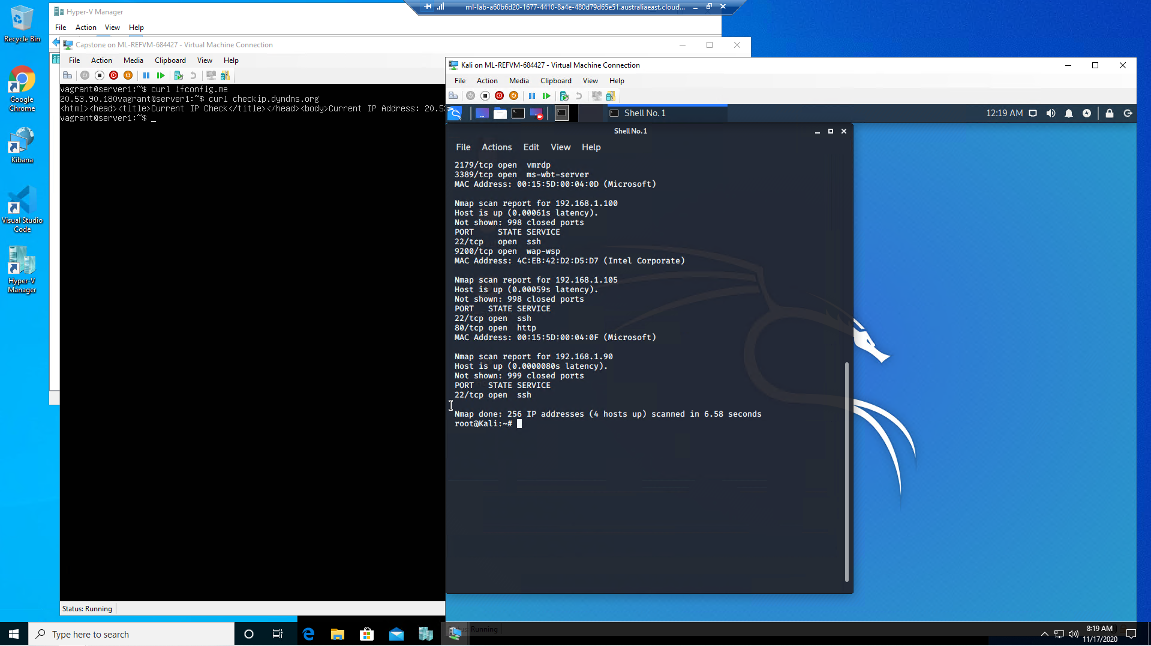

Next action: explore what hosts can be navigated to. This needed to be done from within the kali server.

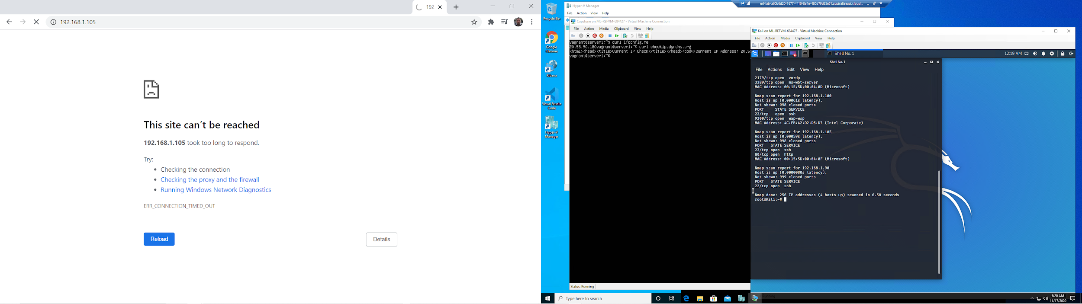

Result: 192.168.1.90 was not accessible.

192.168.1.100 was not accessible.

**192.168.1.105 WAS accessible**.

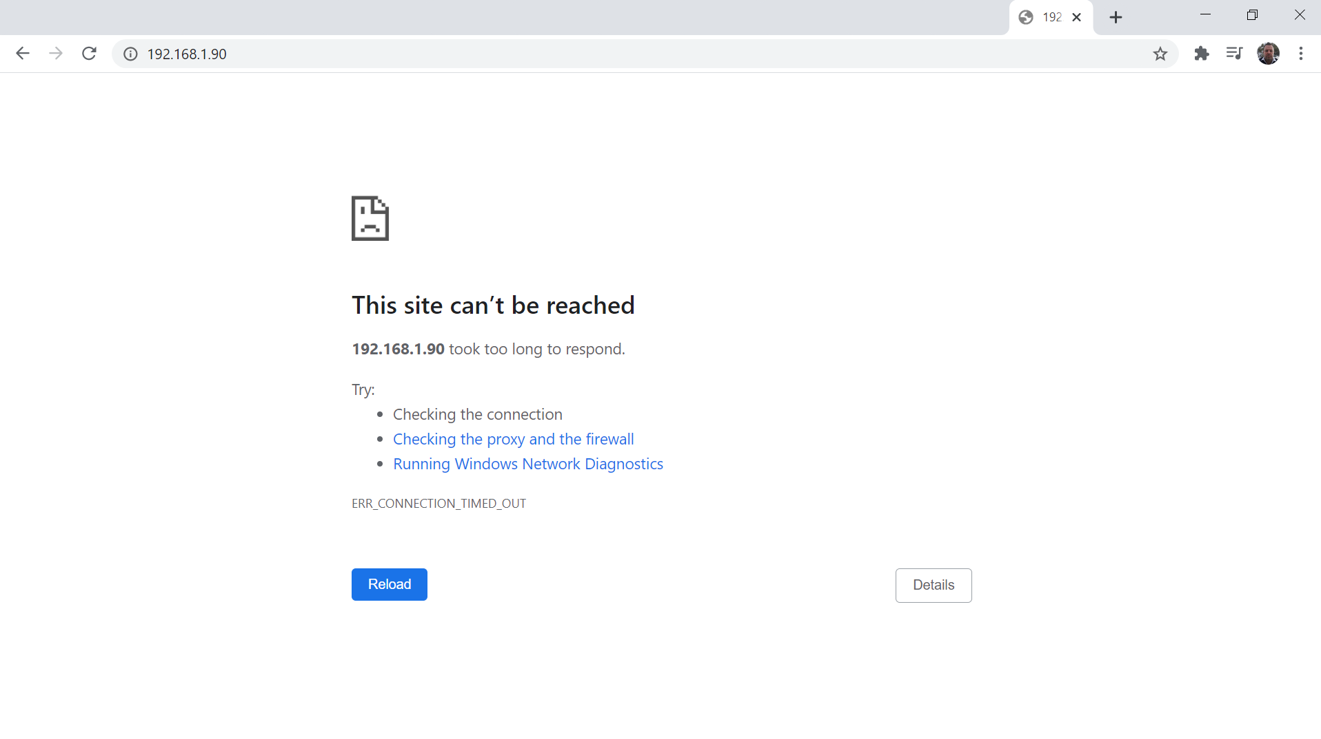

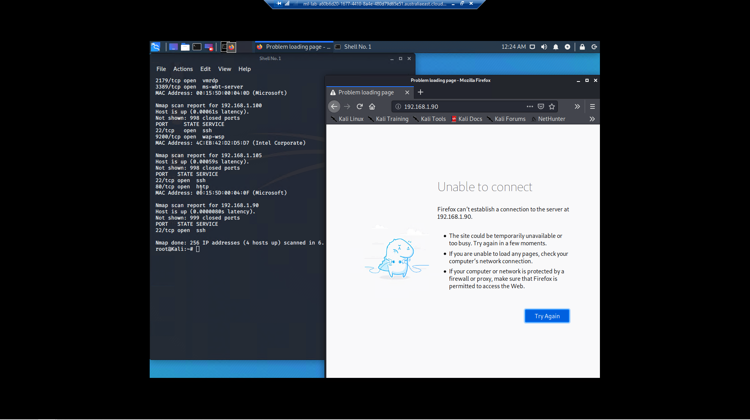

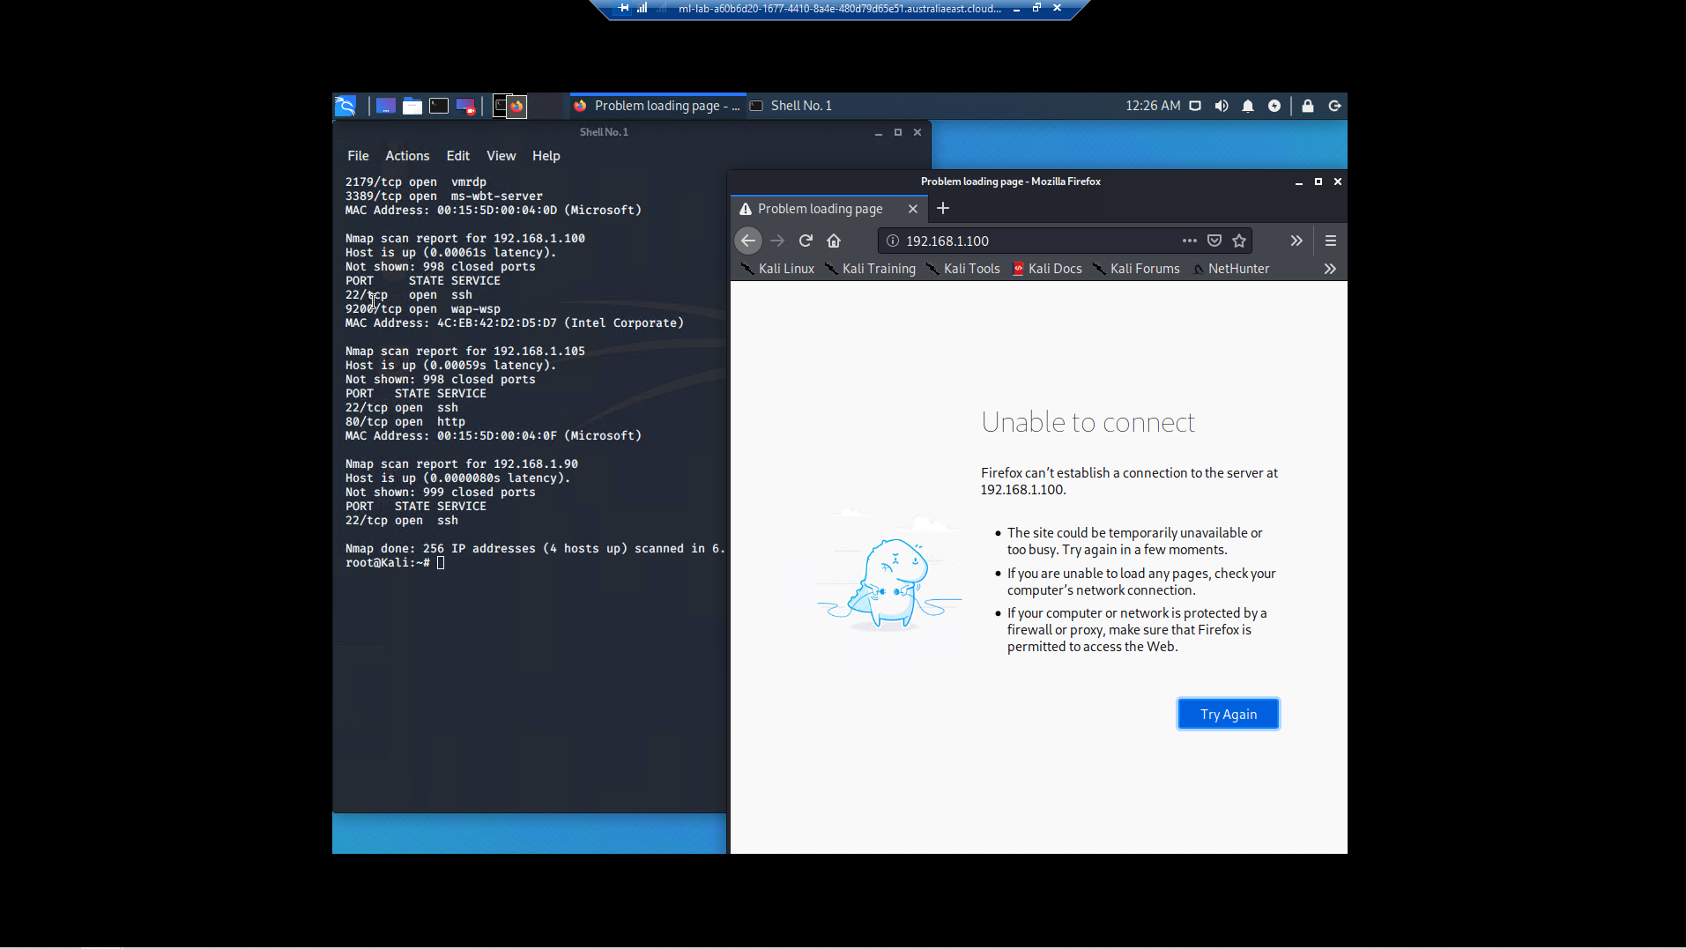

Run nmap

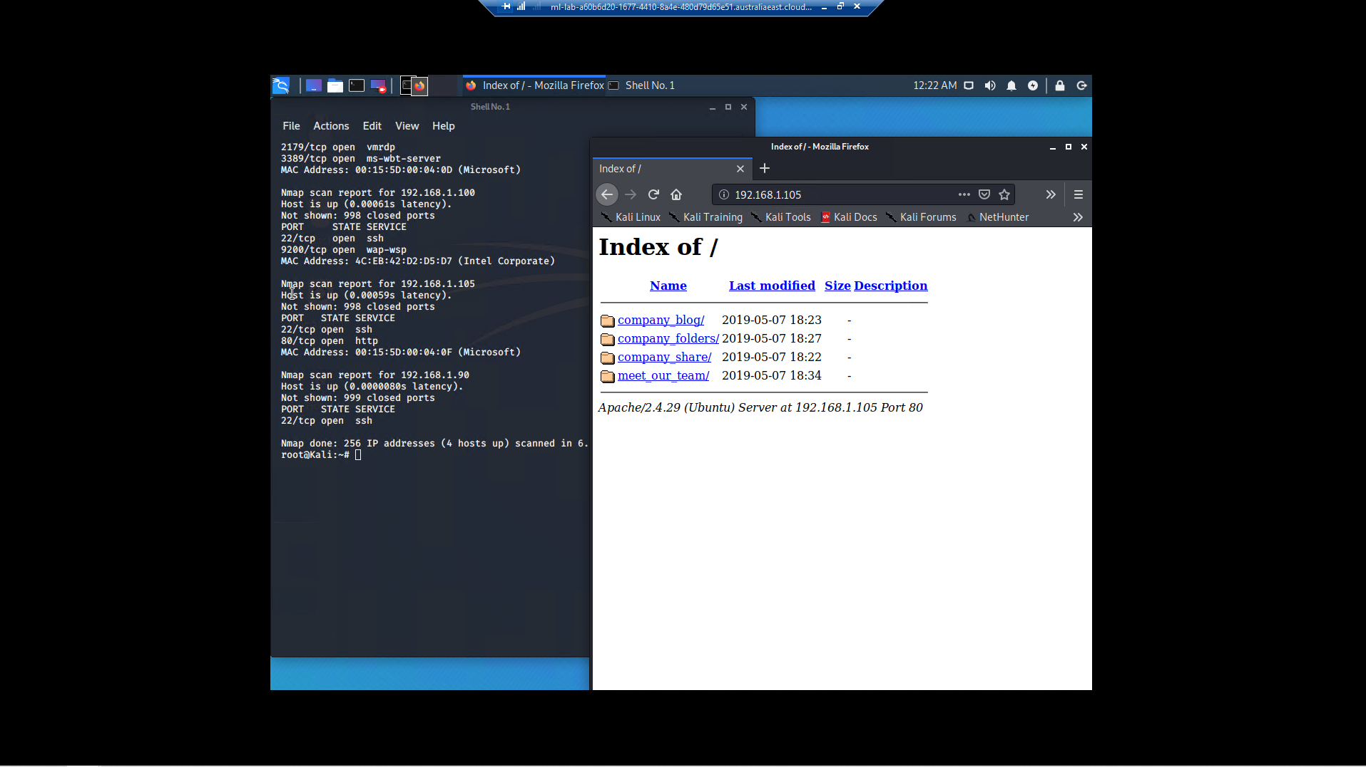

I was able to discover names of 3 employees, and their involvement within the company;

Result: Ryan

Result: Hannah

Result: ashton

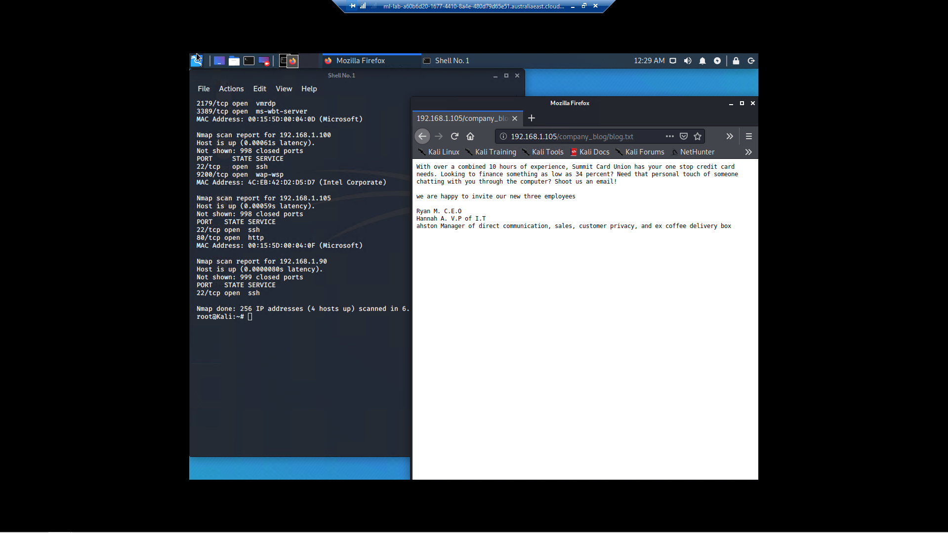

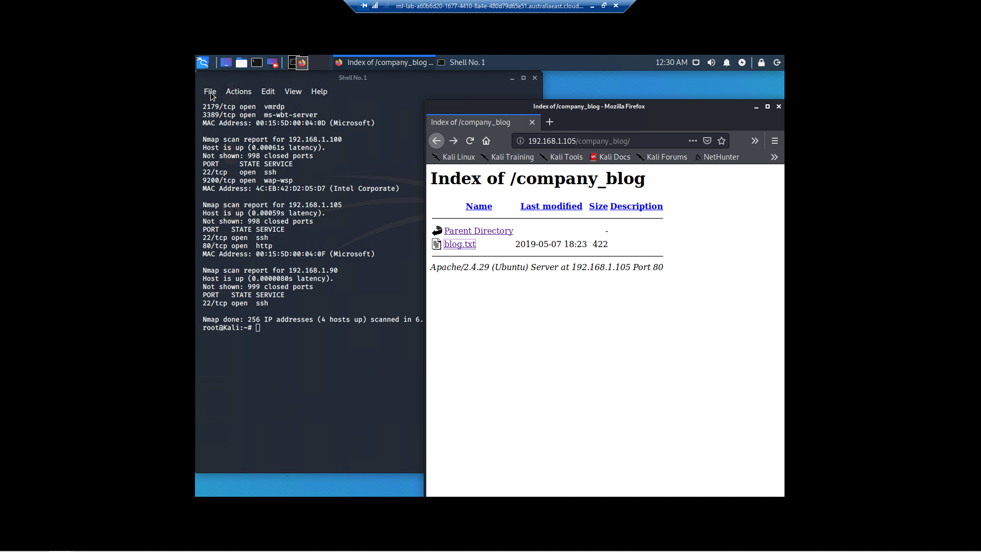

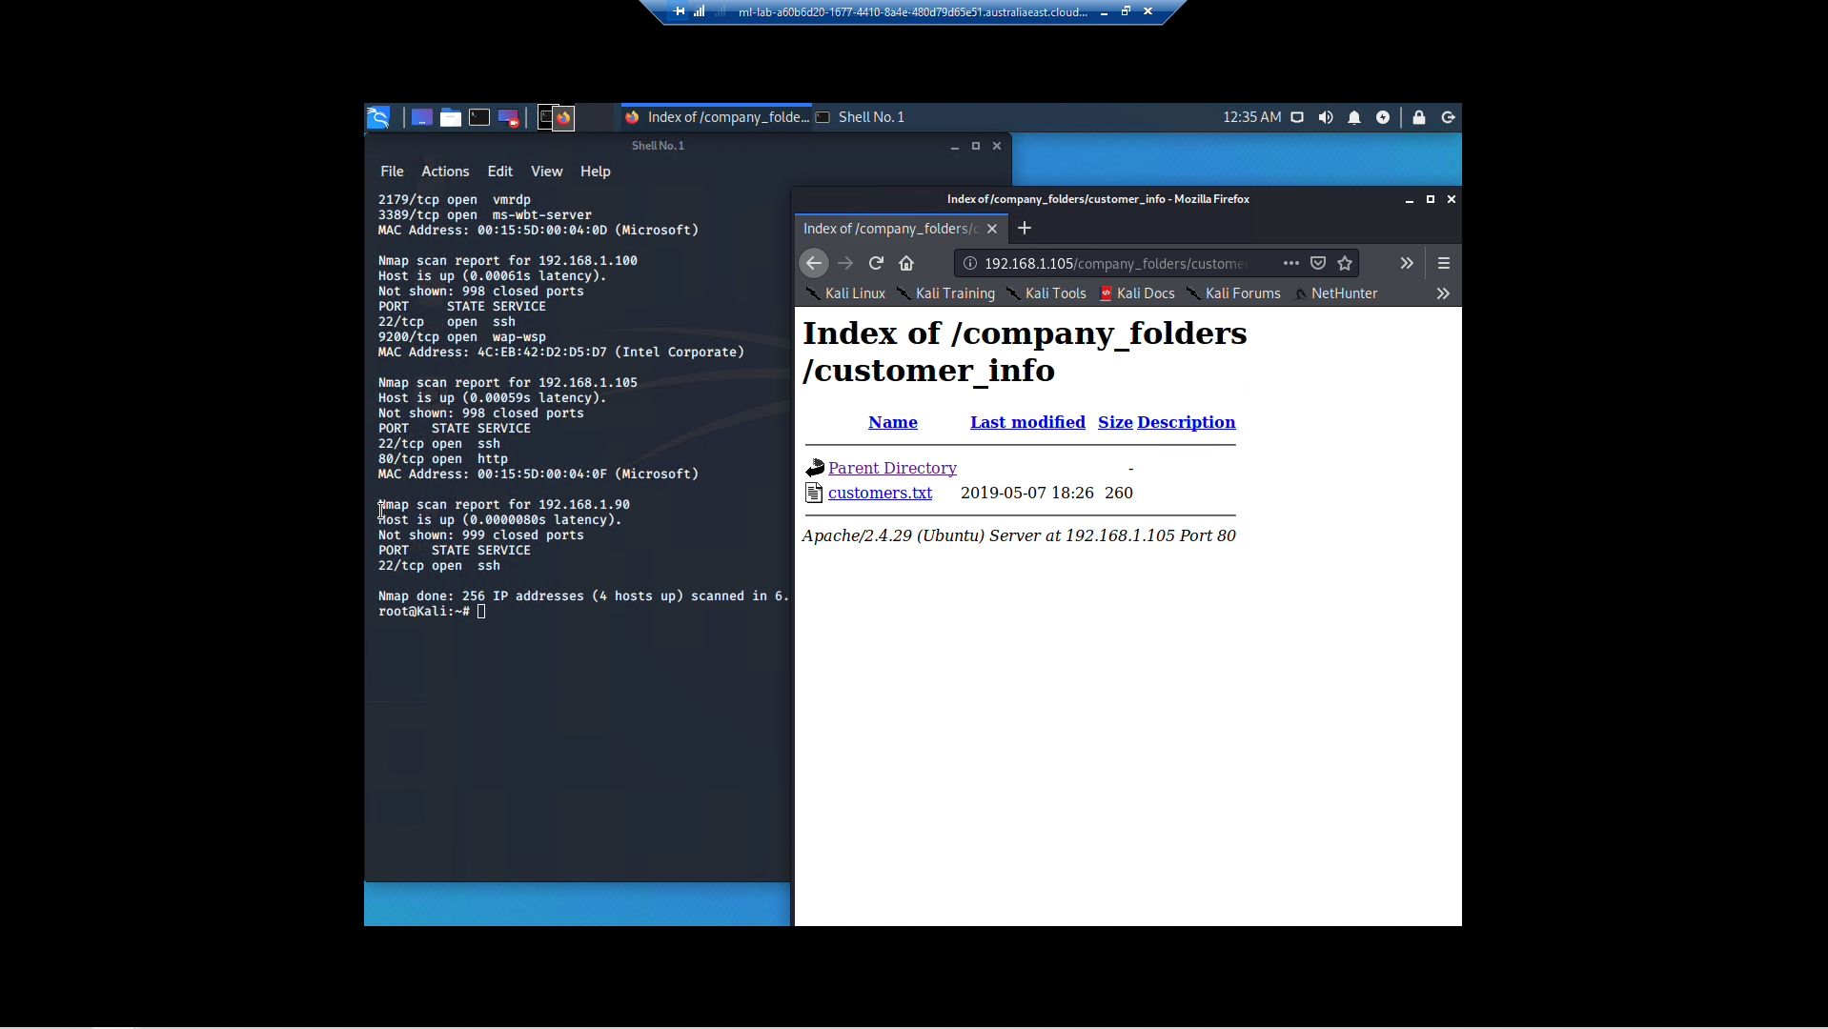

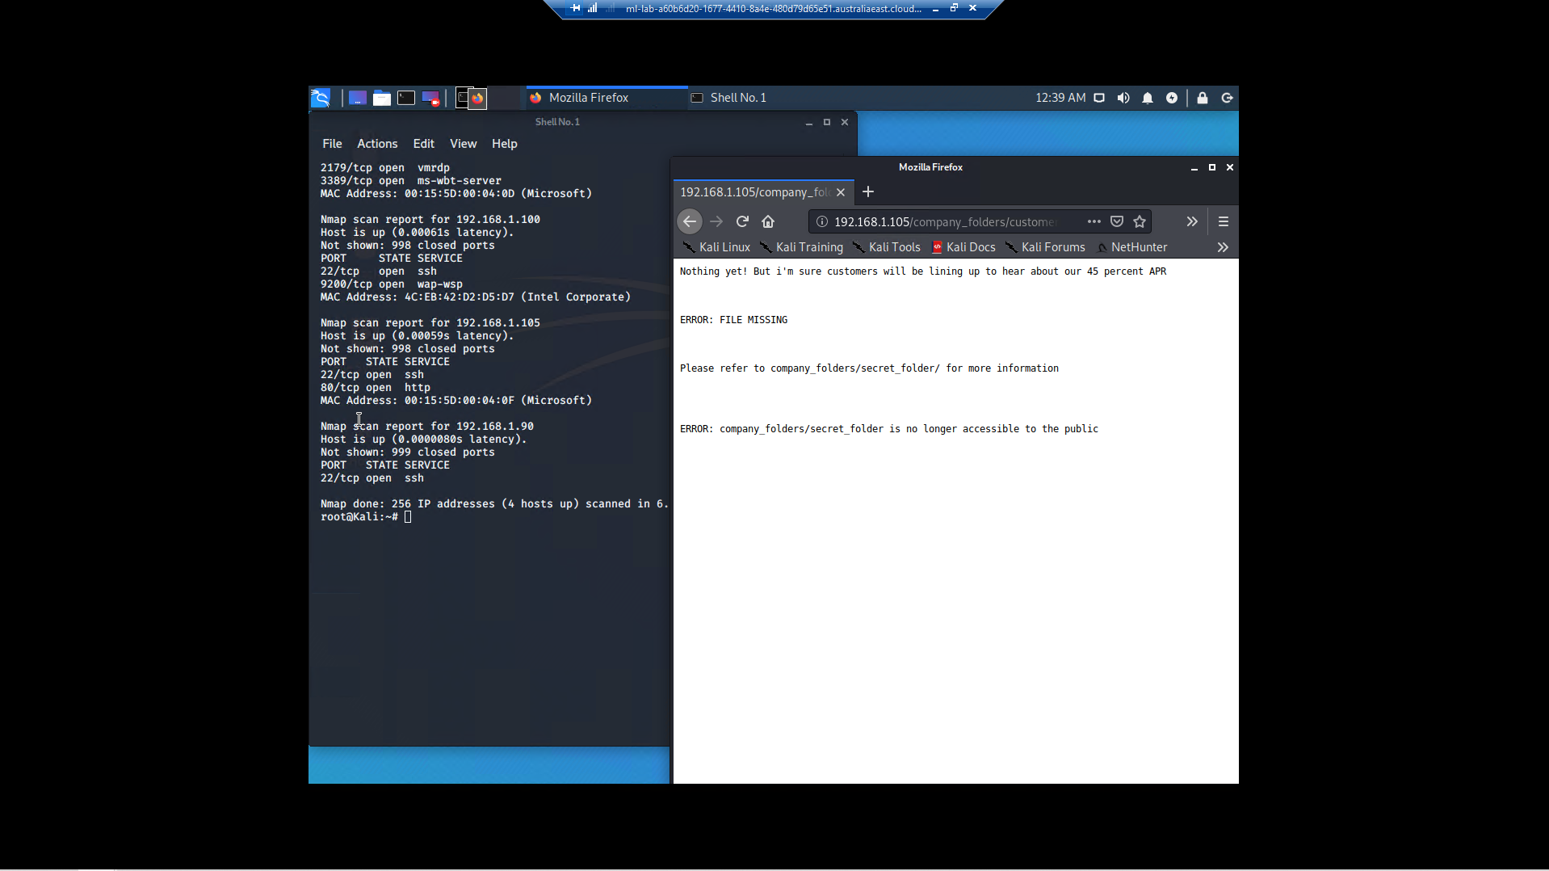

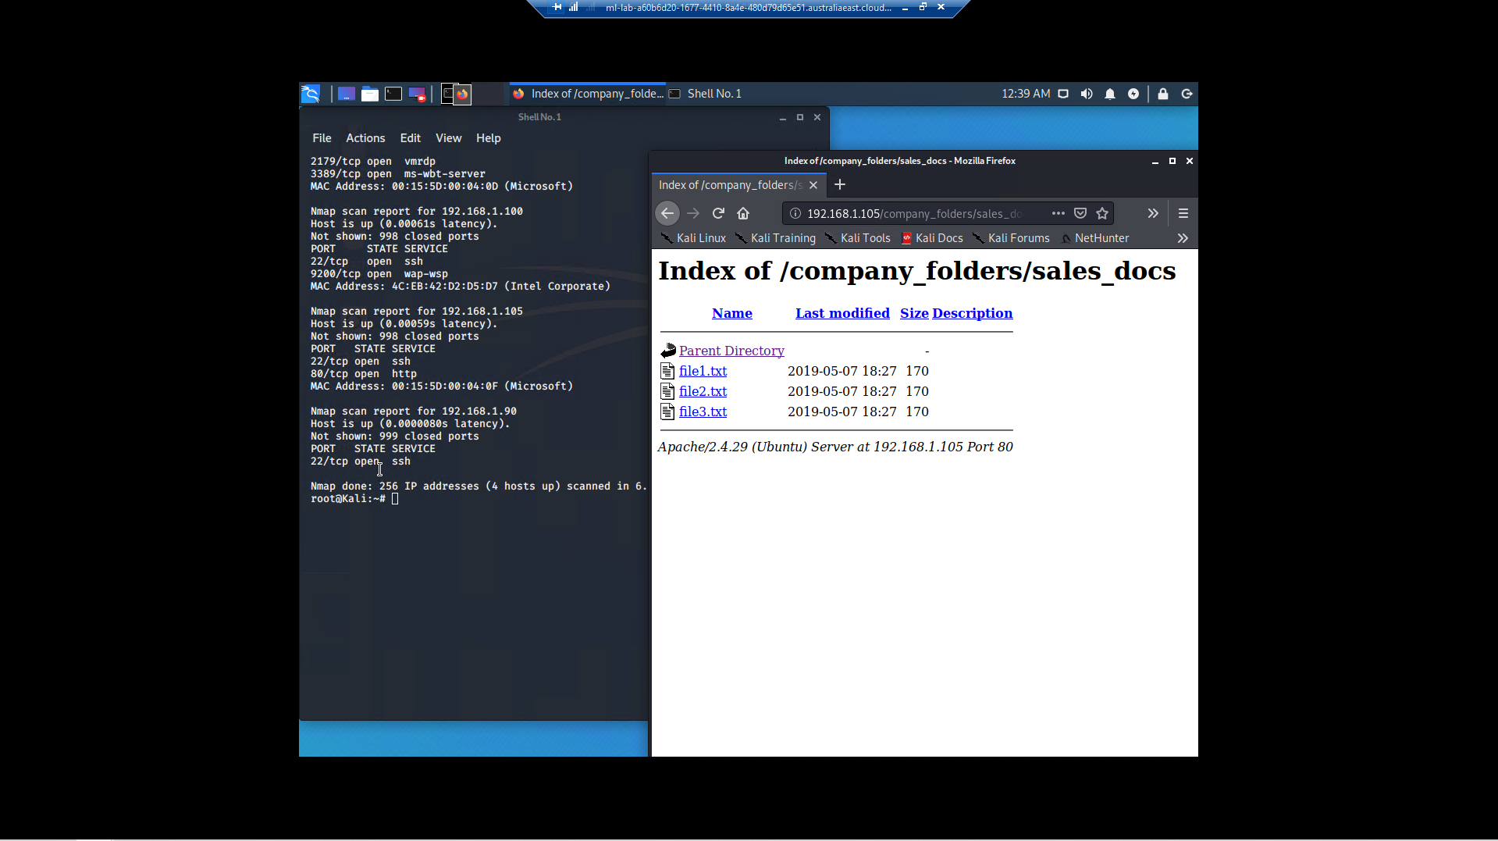

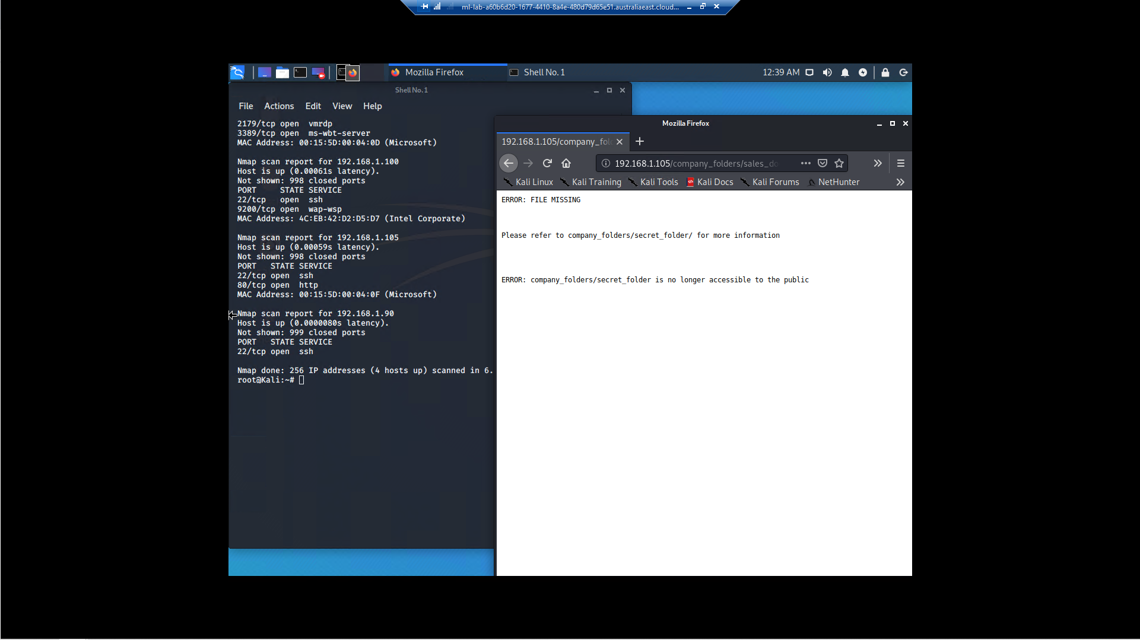

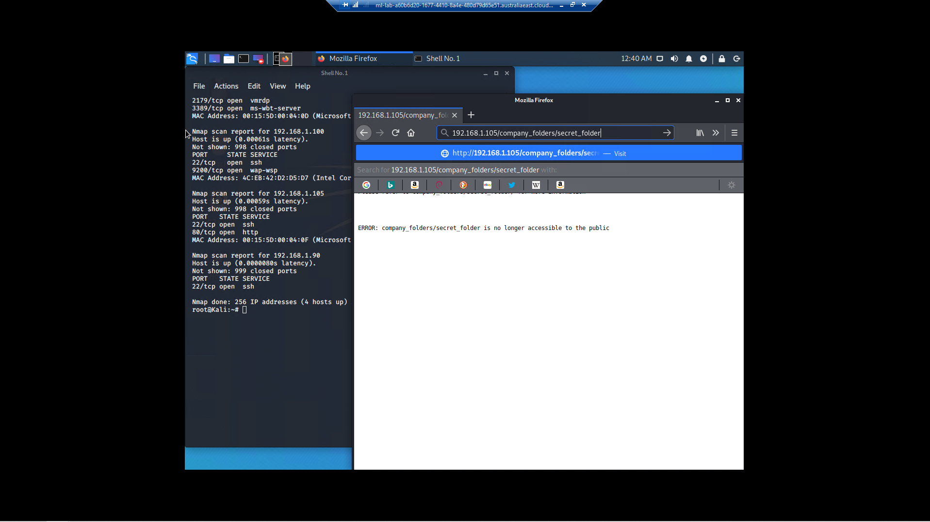As I continued to look, I found suggestions that a /company_folders/secret_folder/ was available.

I was able to explore this by attempting to navigate to http://192.168.1.105/company_folders/secret_folder/

I was presented with a User Name and Password portal:

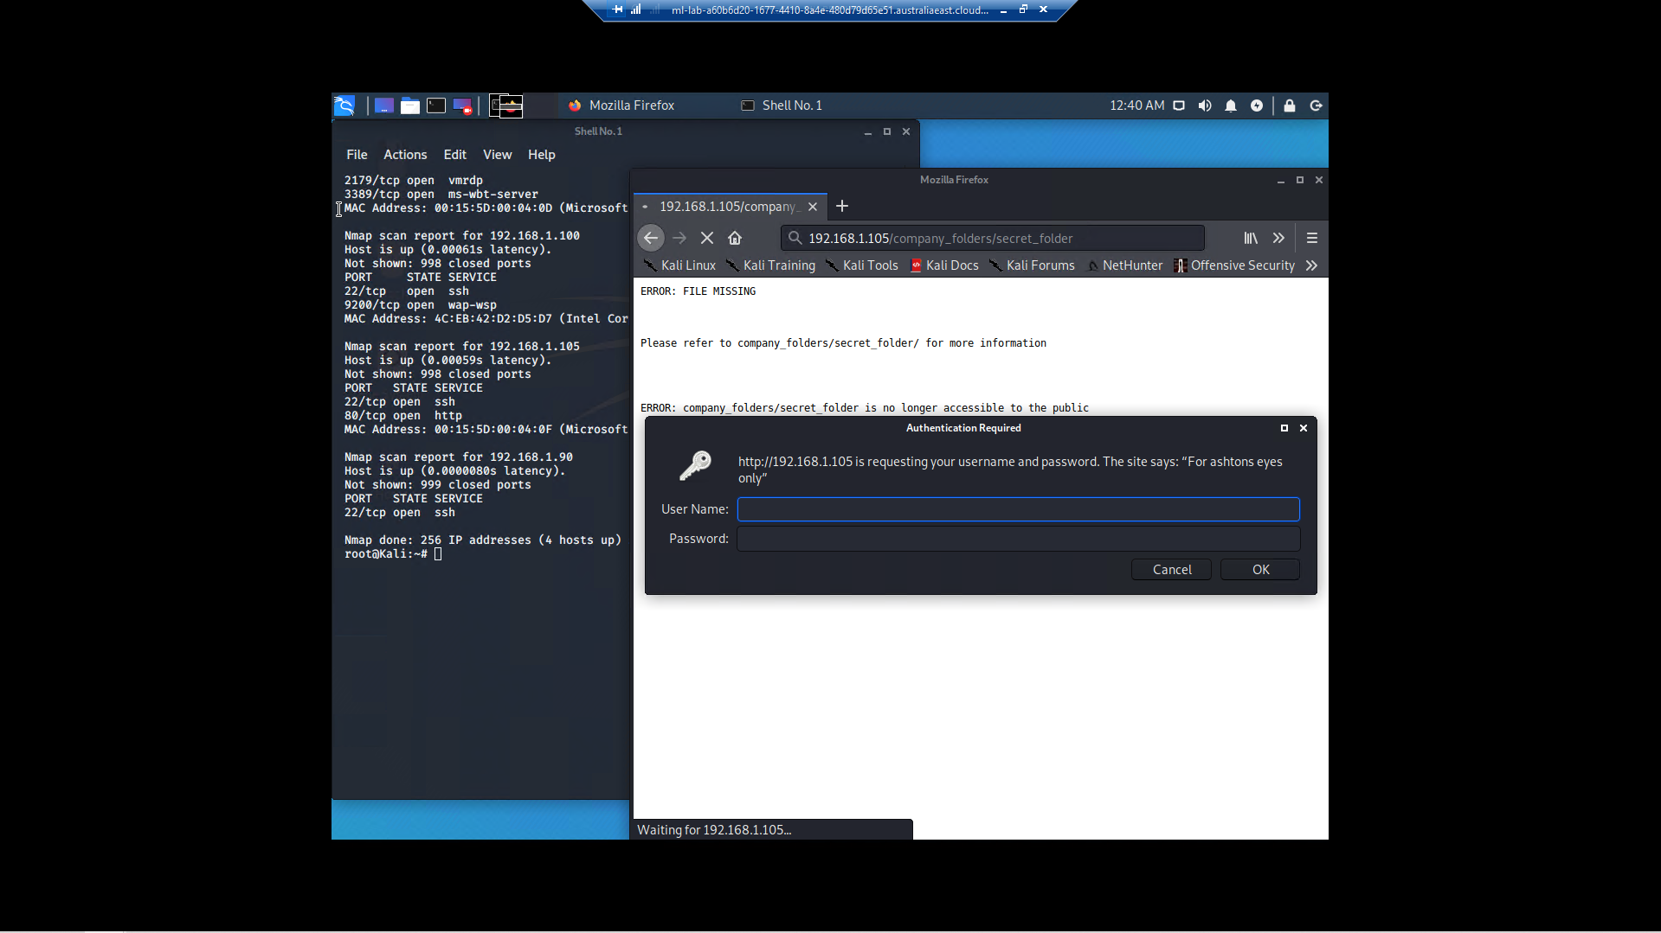

Because I knew that Hydra is pre-installed on Kali linux, I decided to attempt to brute force the credentials.

Within my **RedTeam toolkit** I have various password lists. I decided to start with several of my own compilations, before using the common password resource ‘rockyou.txt’. I downloaded it from my cloud toolkit to the local hard drive. I decided to explore the three Employee’s names as a Username; Ryan, Hannah, and ashton.

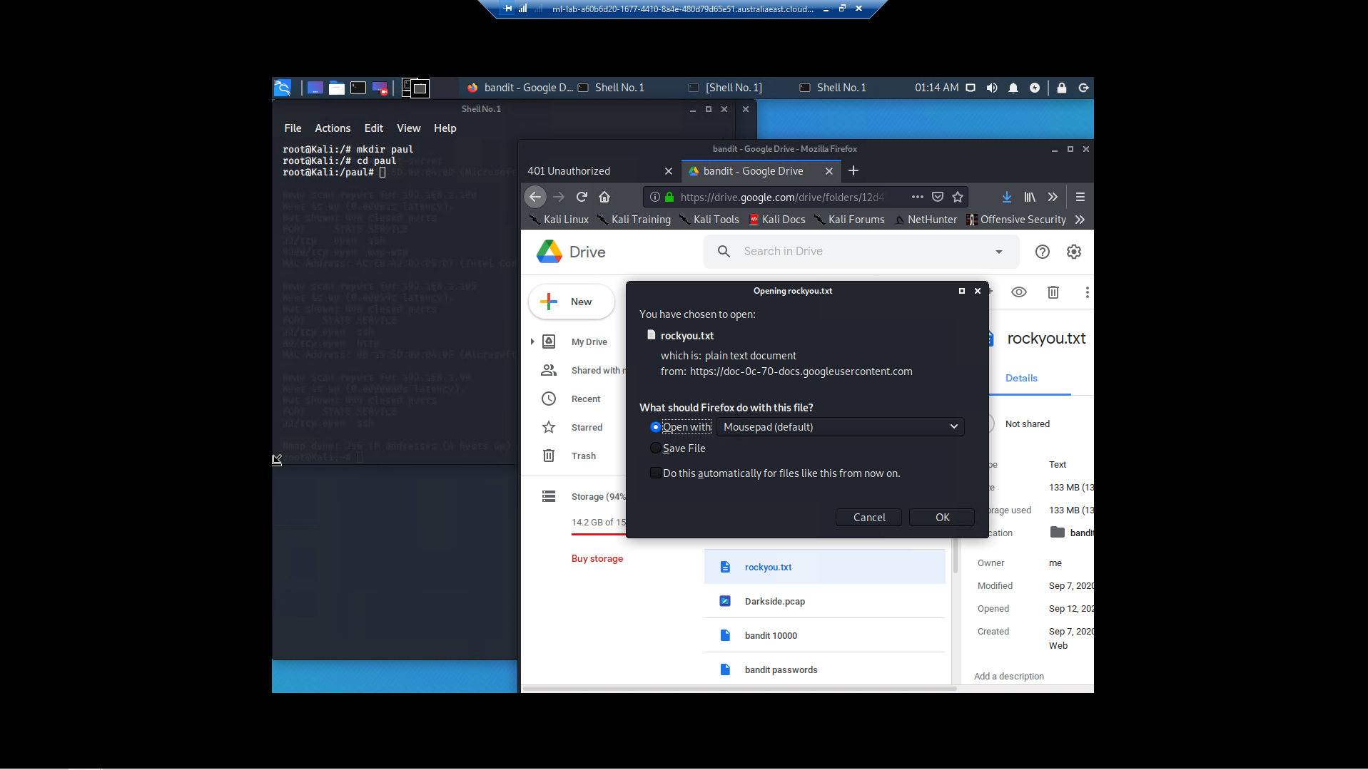

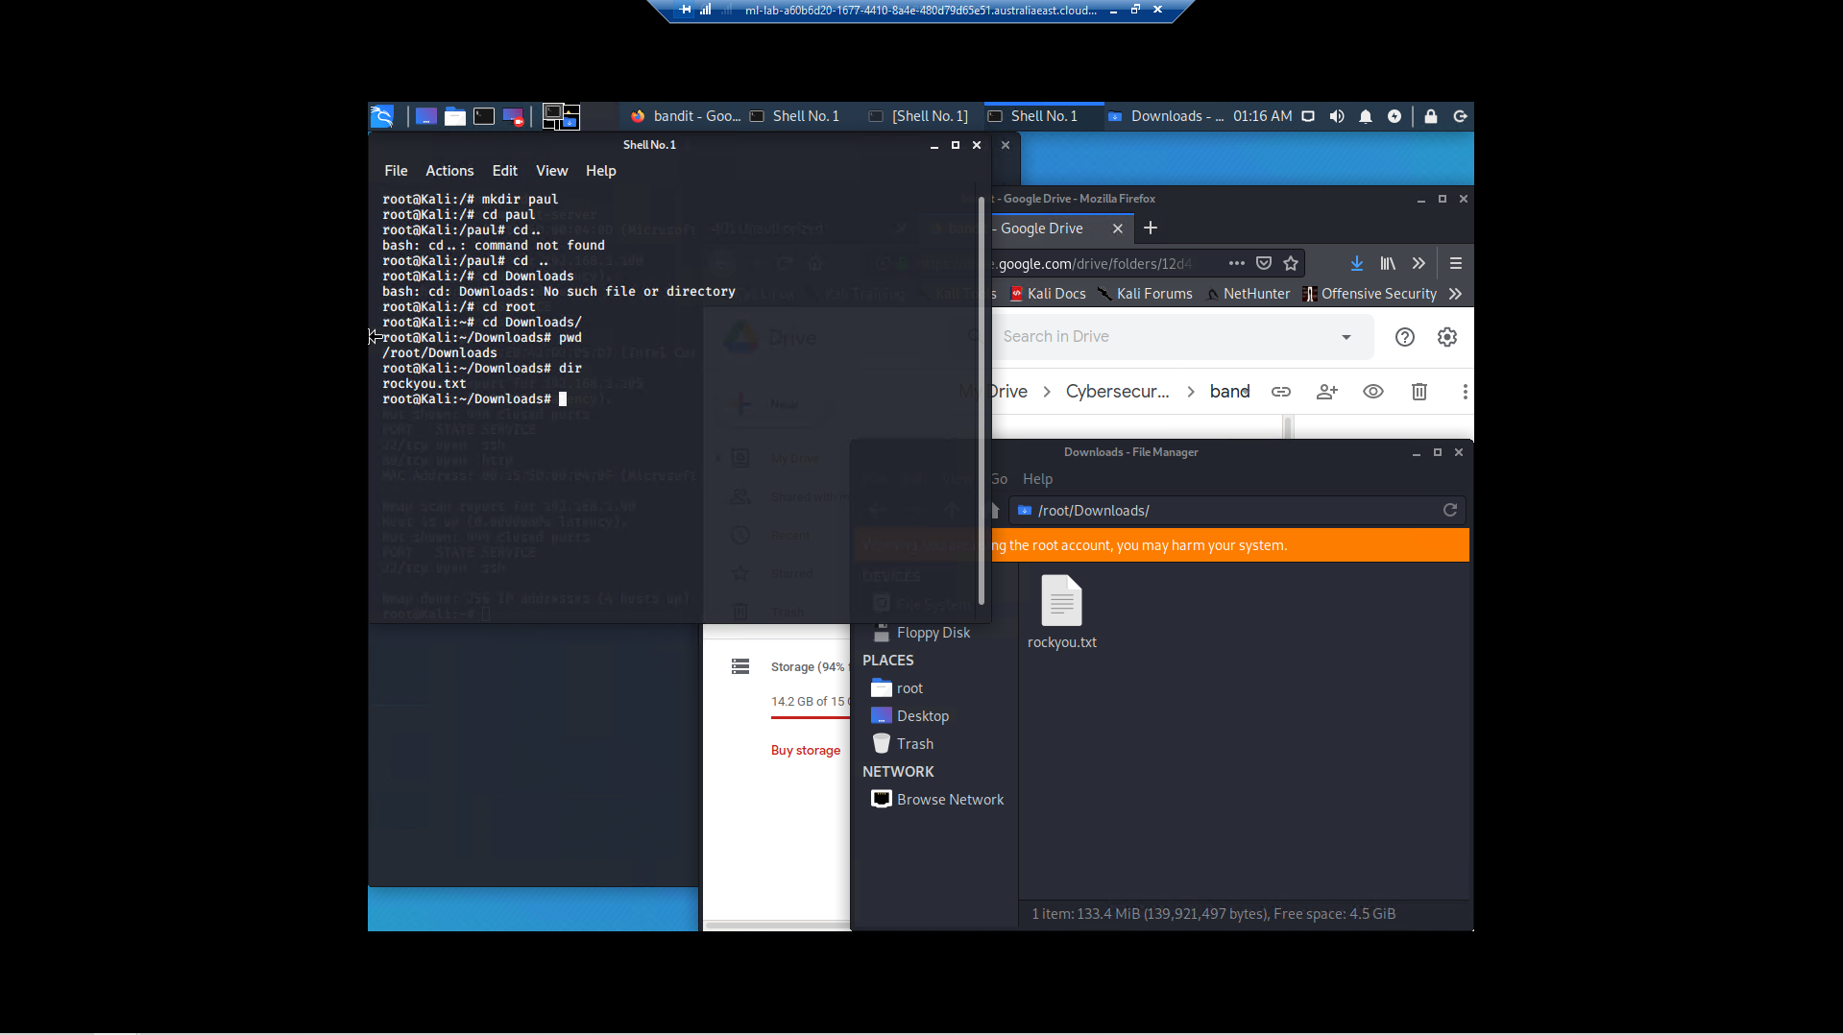

Command: $ hydra -l Ryan -P /root/Downloads/rockyou.txt -s 80 -f 192.168.1.105 http-get /company_folders/secret_folder

Result: no success

Command: $ hydra -l Hannah -P /root/Downloads/rockyou.txt -s 80 -f 192.168.1.105 http-get /company_folders/secret_folder

Result: no success

Command: $ hydra -l ashton -P /root/Downloads/rockyou.txt -s 80 -f 192.168.1.105 http-get /company_folders/secret_folder

Result: $ login: **ashton**

Result: $ password: **leopoldo**

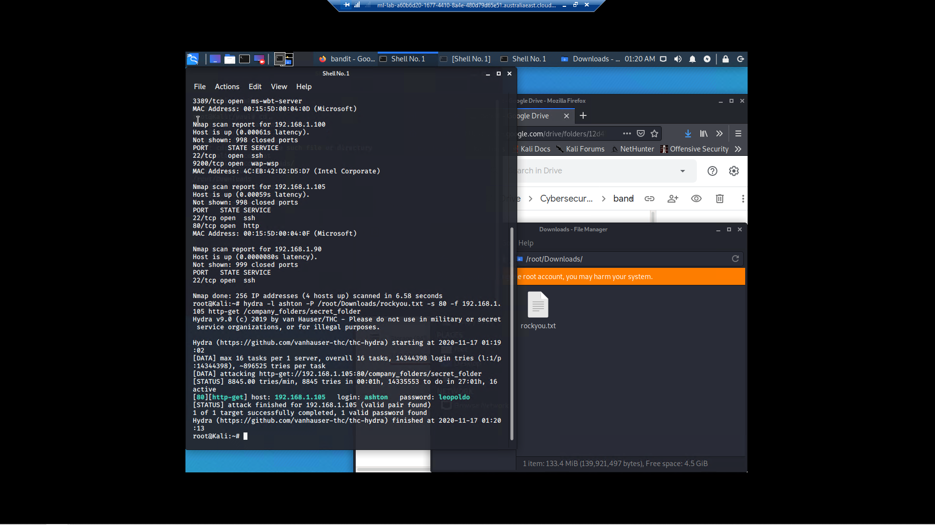

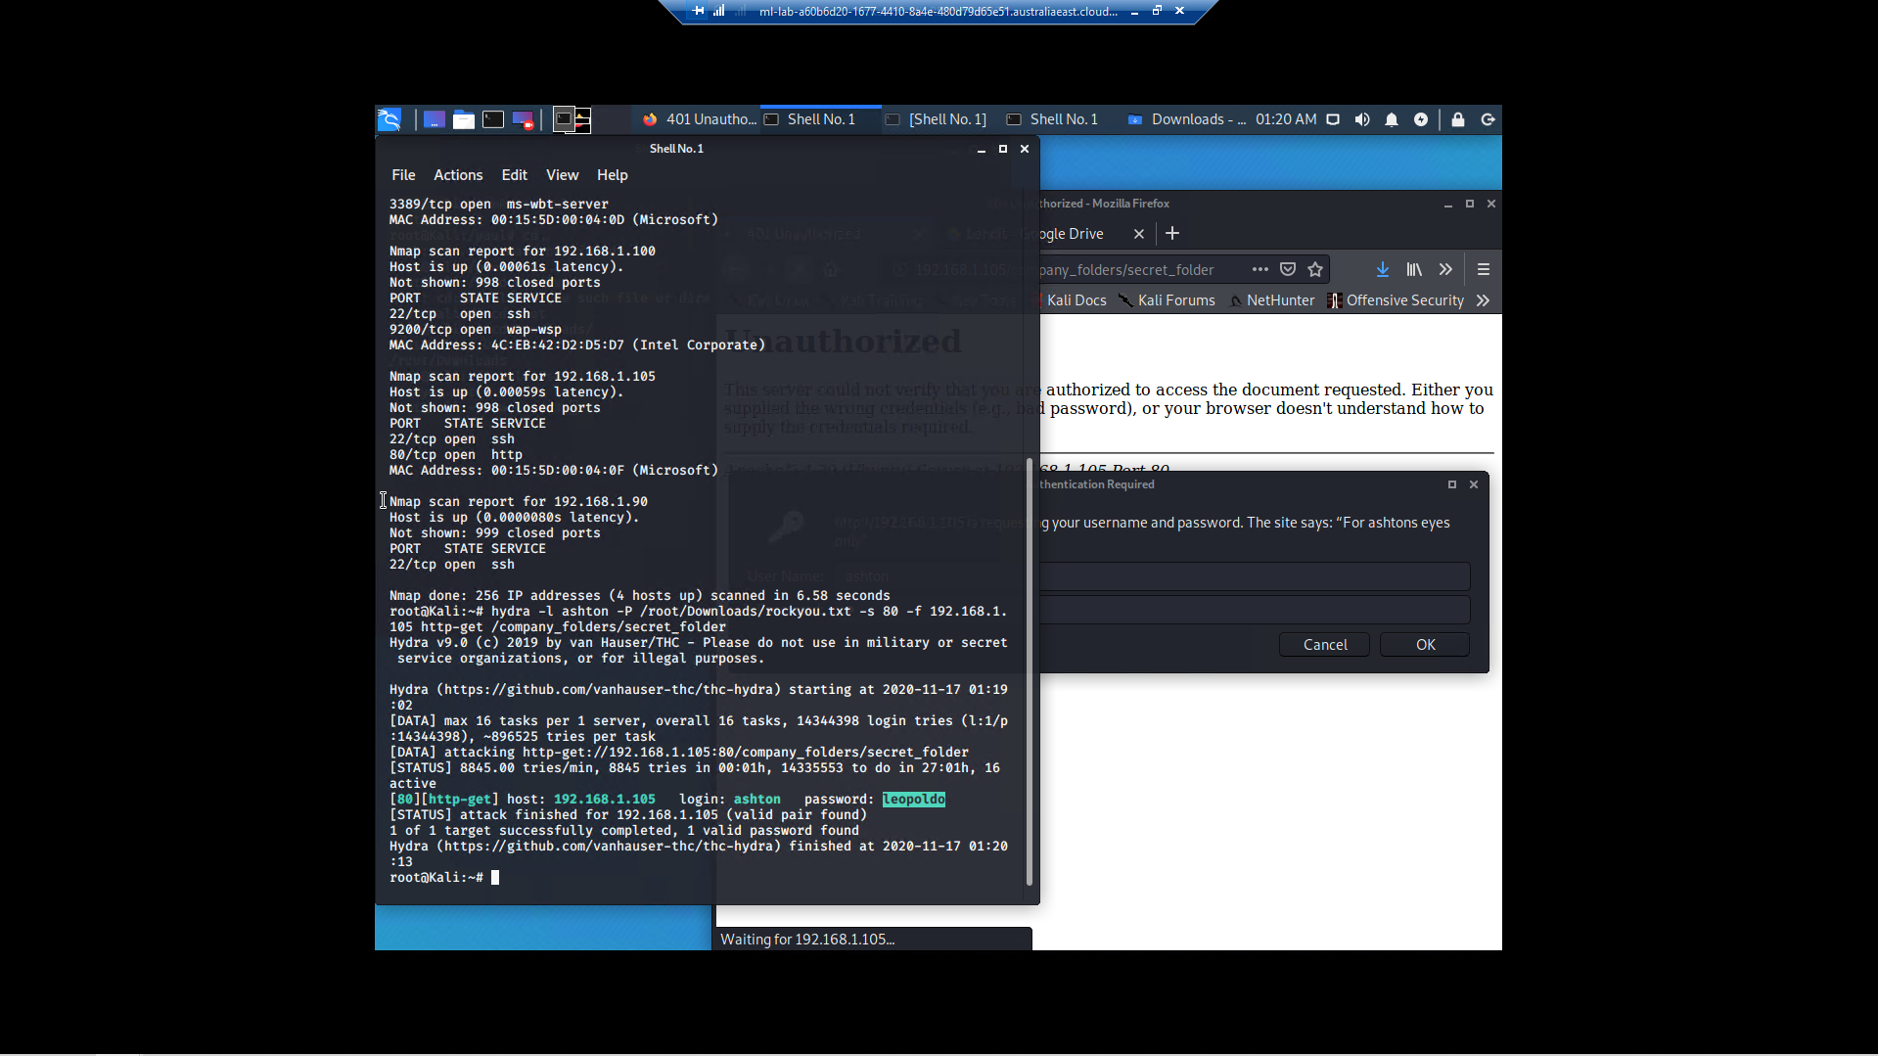

I then entered the **Username** ashton and **Password** leopoldo to gain access to the secret_files folder.

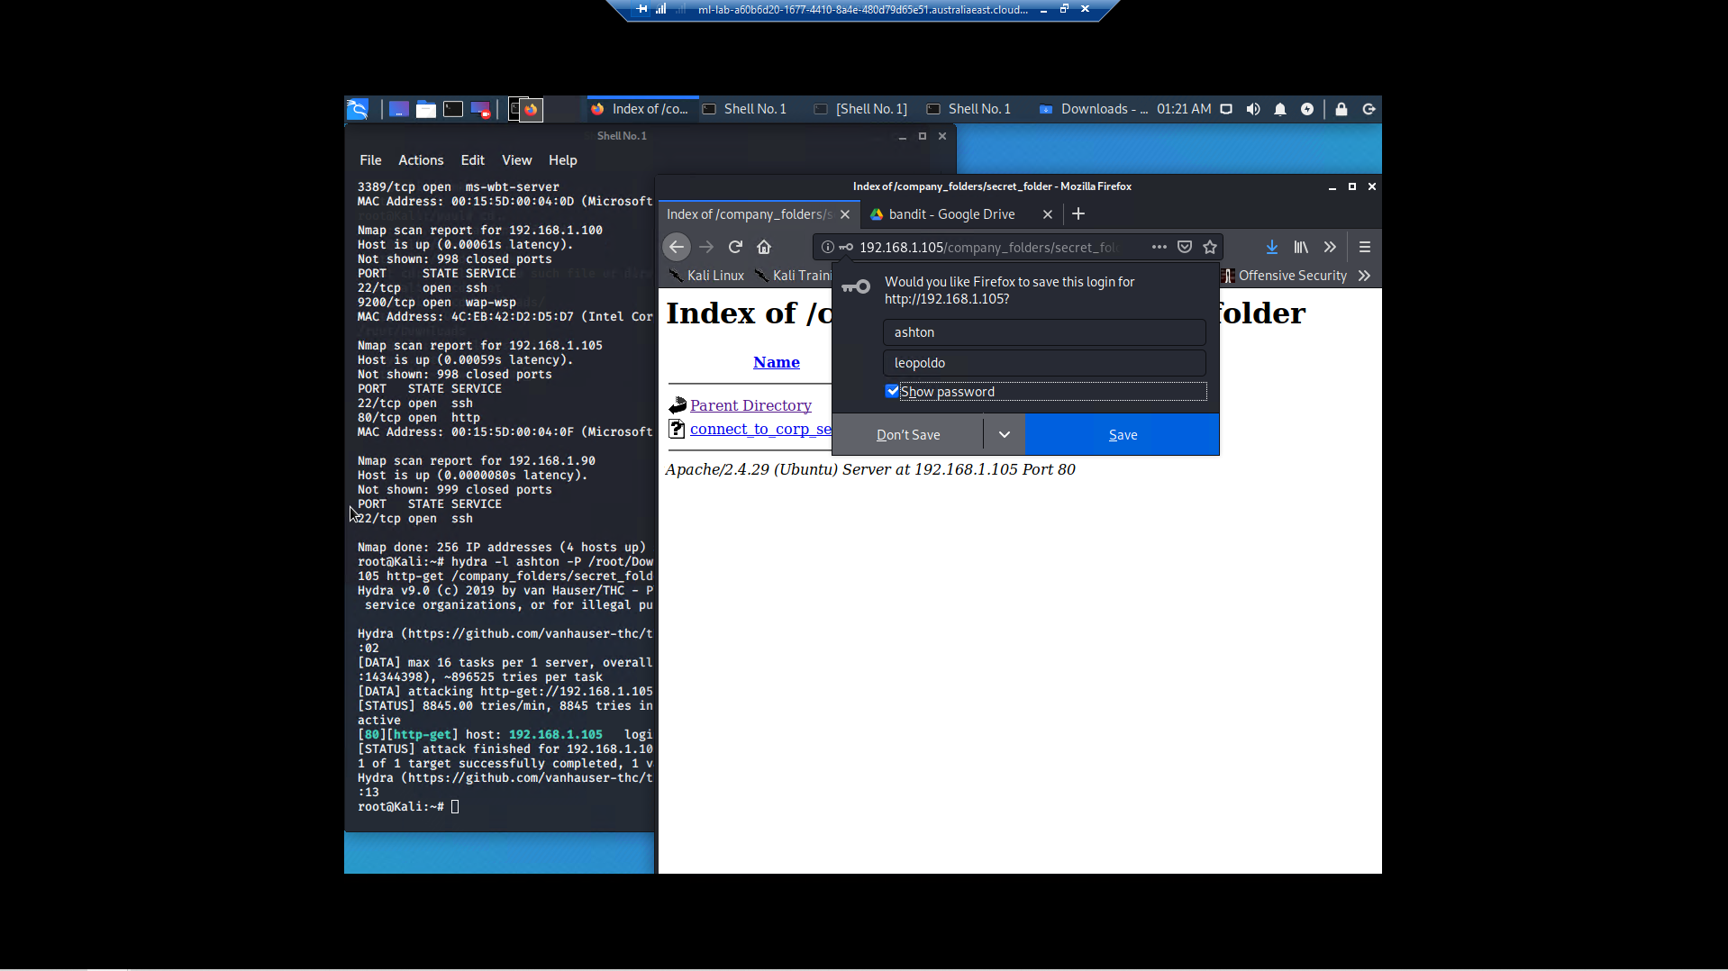

Result: **Hash found**

Result: **webdev folder reference found**

Result: **dav://172.16.84.205/webdav/**

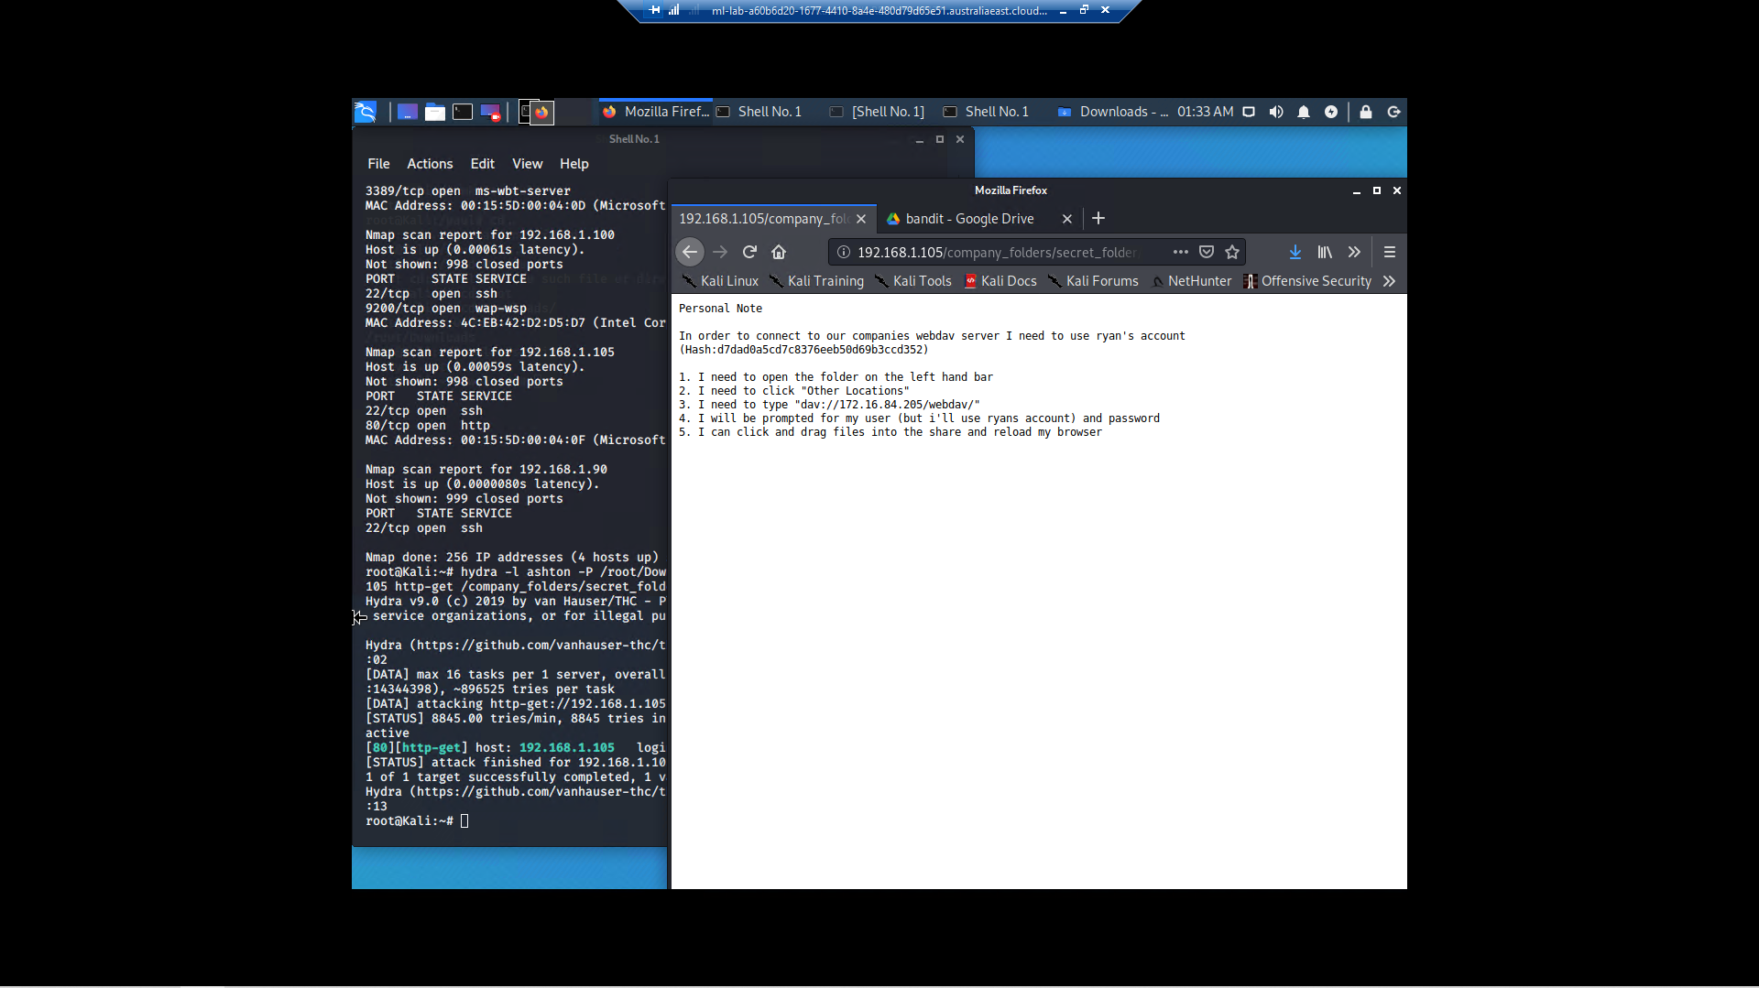

Result: **172.16.84.205/webdav/** was not accessible.

Command Used: I used [**https://www.iplocation.net/**](https://www.iplocation.net/)to gain information about the IP address 172.16.84.205, however this IP Address is currently private. I made the assumption that this IP address may be an old IP address and reference to the new IP address had not been updated within the secret_folder as yet.

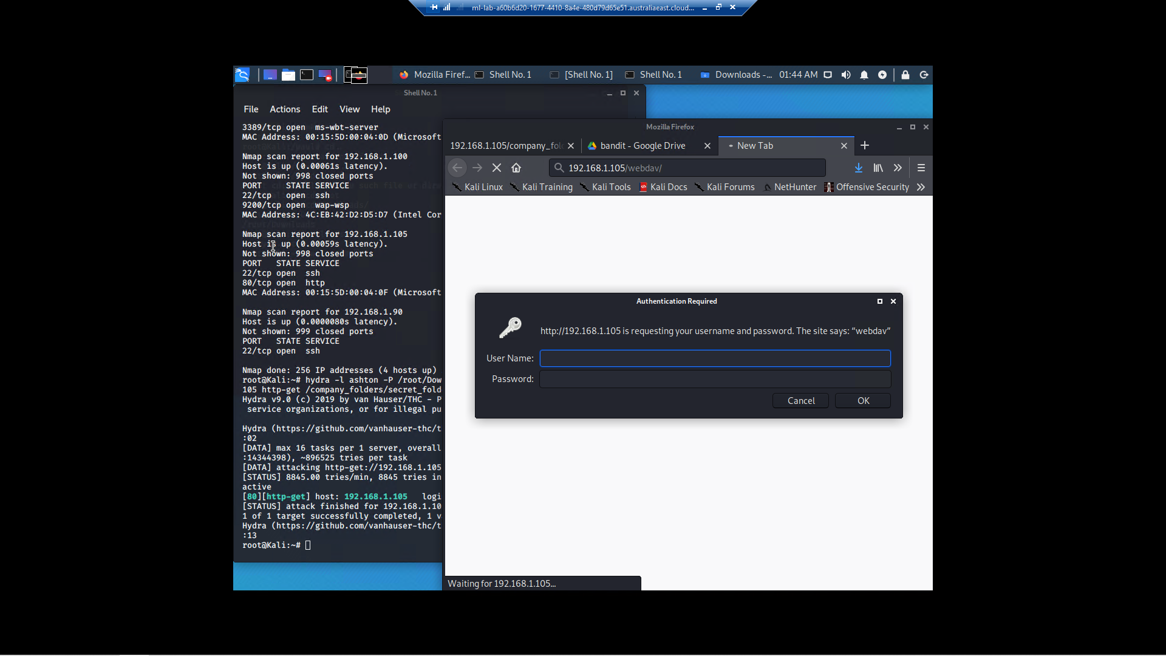

Then, I substituted the IP address with the known IP address 192.168.1.105 and was presented with another login popup.

At first, I tried to enter the password hash within the password form.

Result: no success

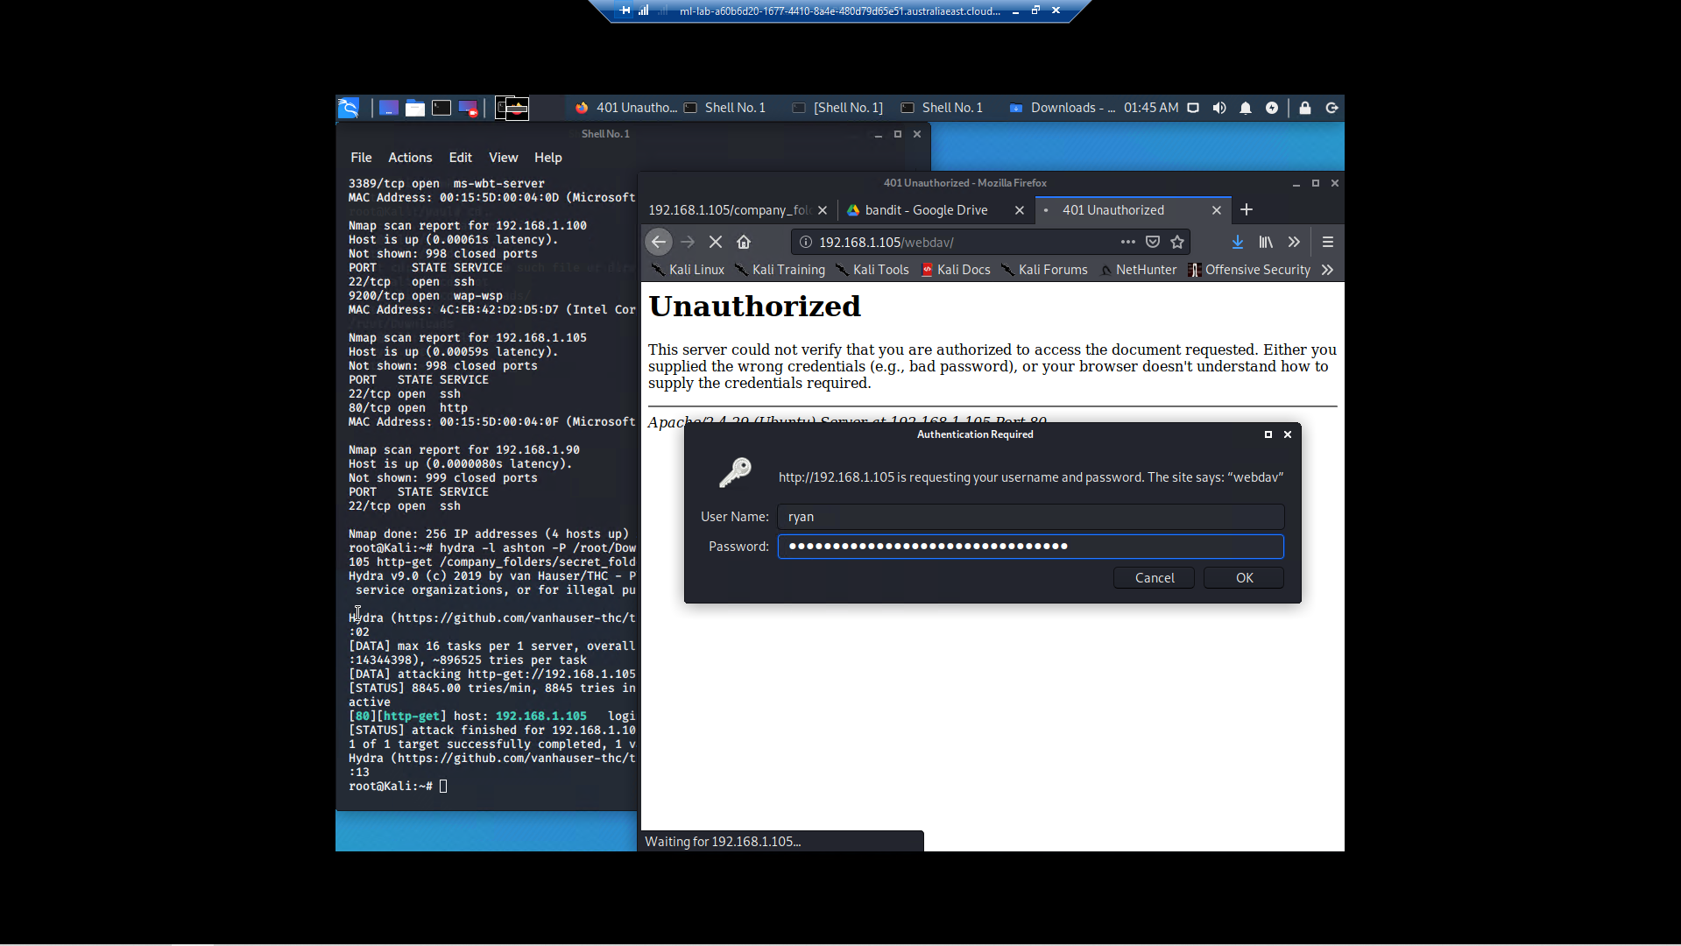

I then decided to google ‘crack password hash’ and I used the first option available.

Action Taken: Used **crackstation.net** to crack Password Hash

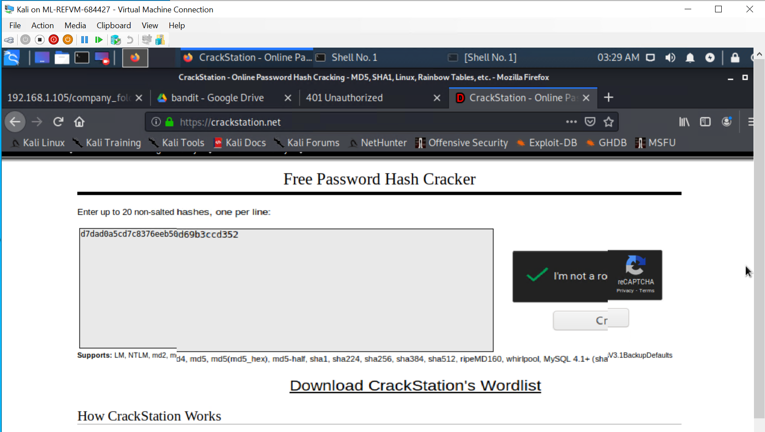

Result: **password found: linux4u**

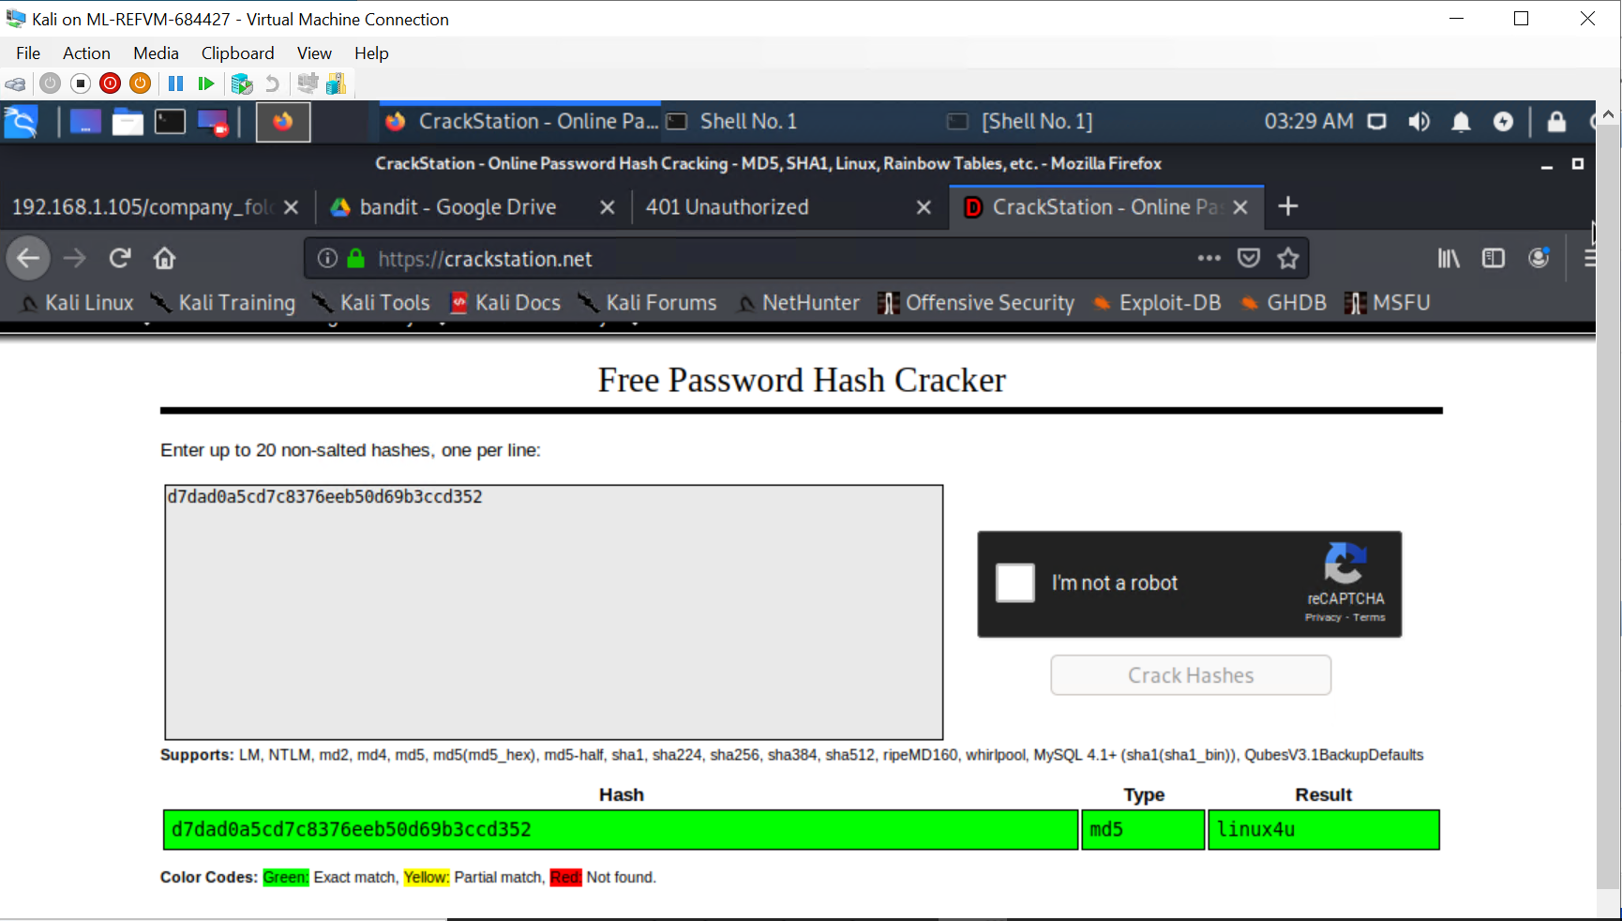

Then I returned to my 192.168.1.105/webdav/ webpage to try and access, using known Staff names, and the cracked password.

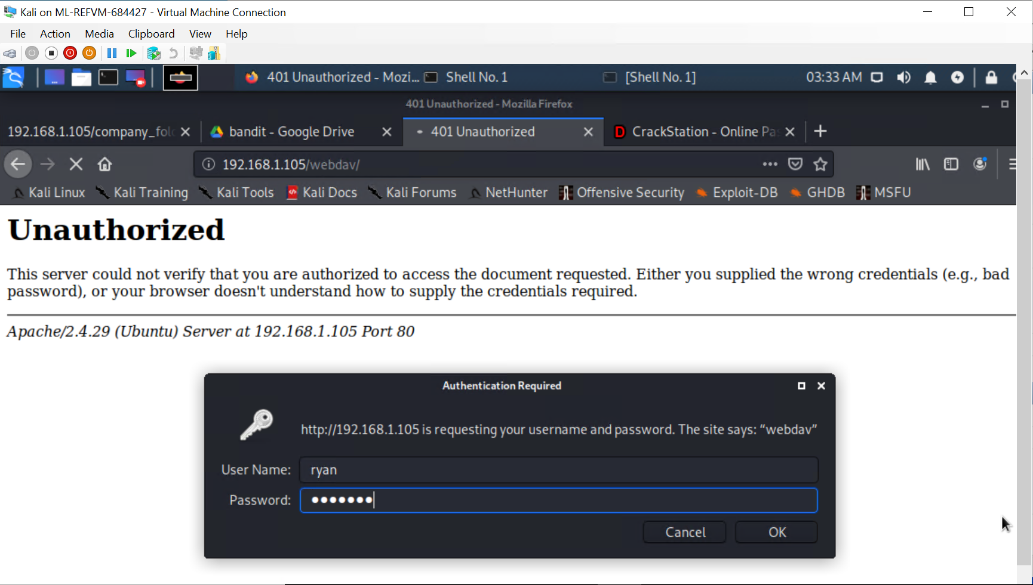

Result: **Successfully accessed the /webdav/ folder.**

Found: **passwd.dav**

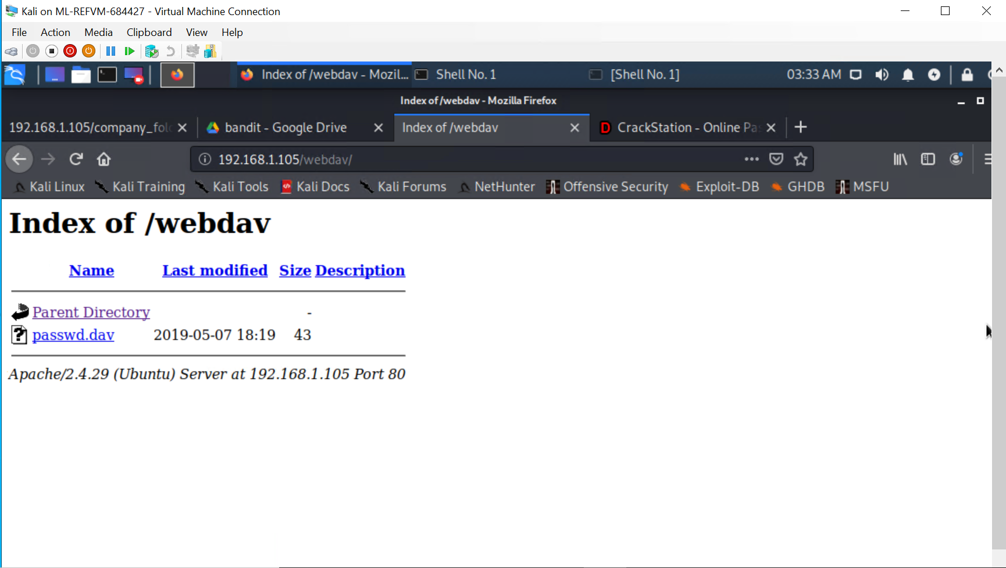

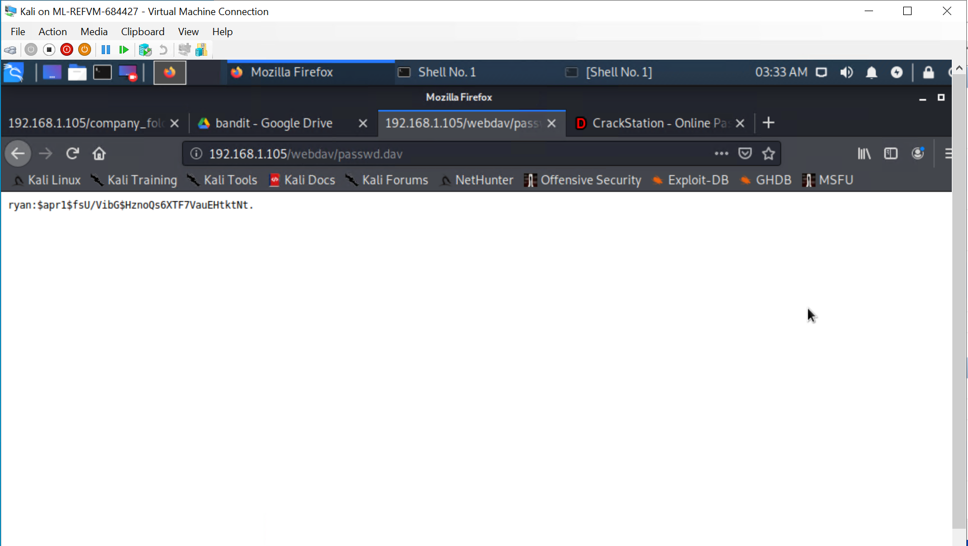

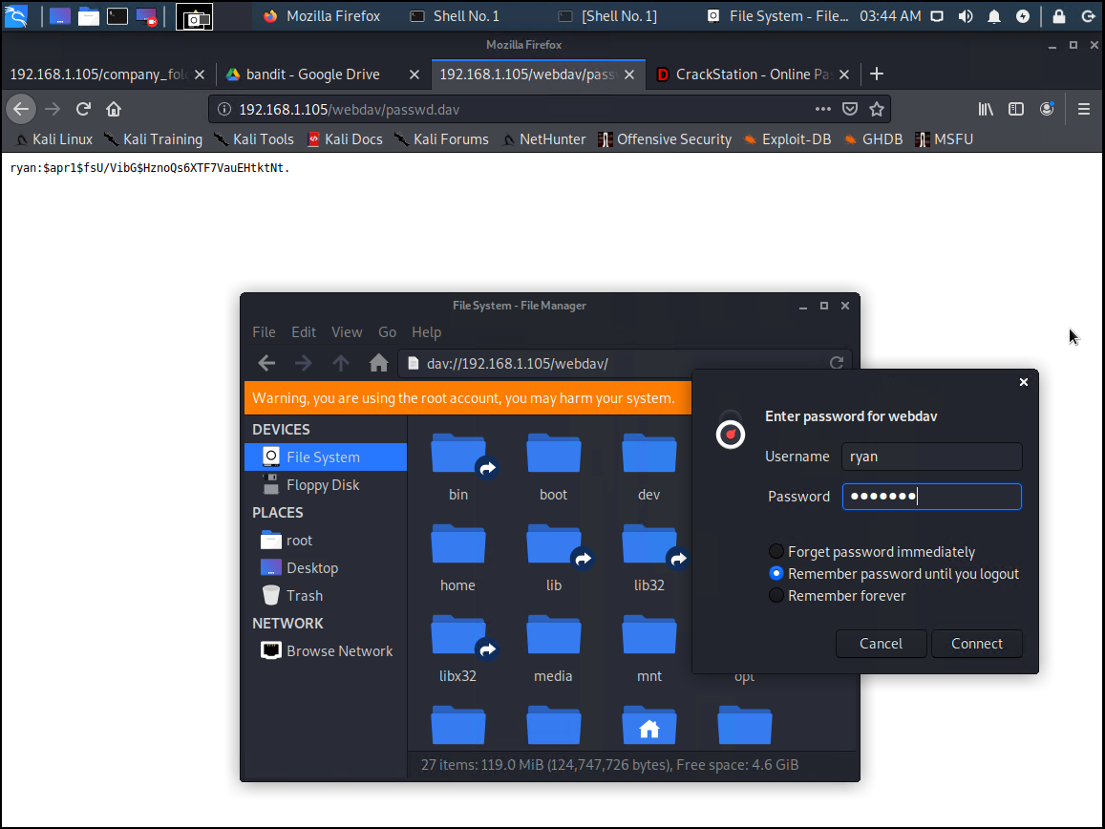

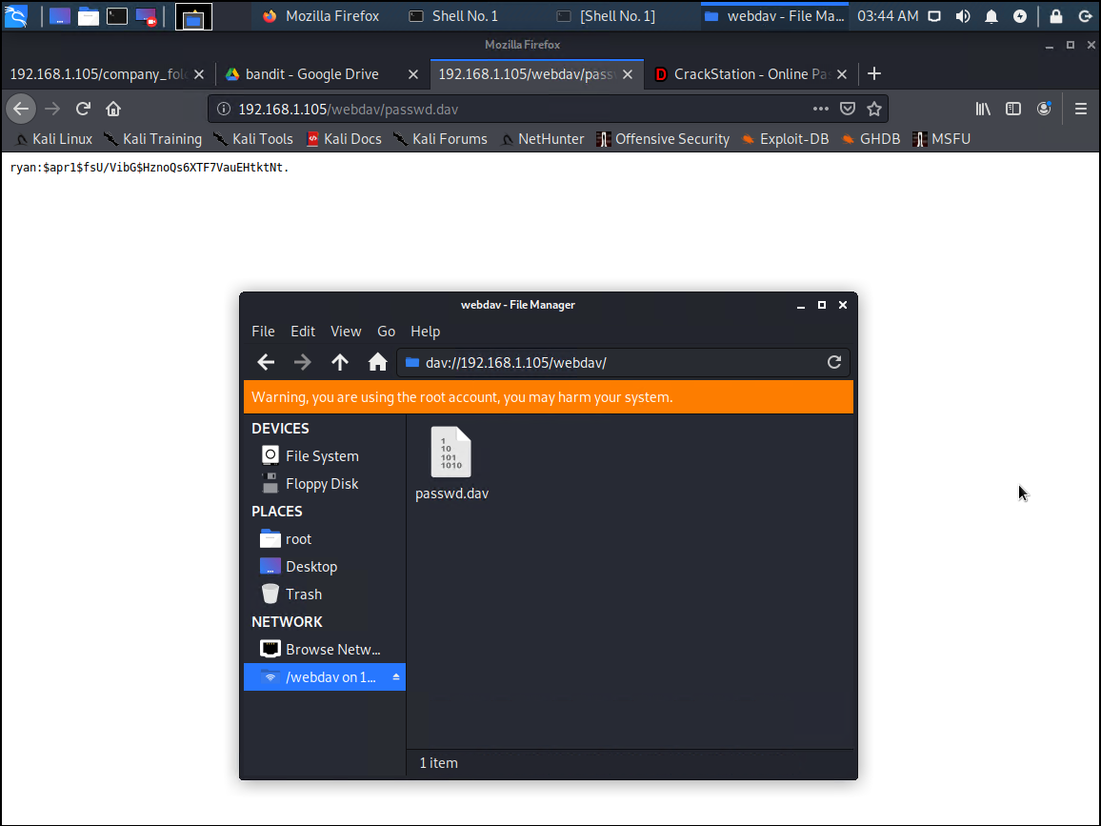

**DAV file** types save videos in an encrypted format using modified MPEG compression. Because **DAV files** are encrypted, popular media and MPEG players and editing programs can't play or edit the **files.**

I used [www.online-convert.com](http://www.online-convert.com) to convert the *.dav file to an *.mpg file, which provided the following display:

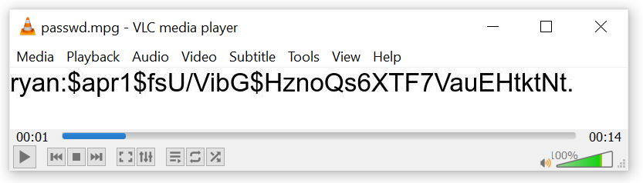

[**https://www.online-convert.com/result#j=f6bb29f9-6017-4b53-a7e7-b02a44331f63**](https://www.online-convert.com/result#j=f6bb29f9-6017-4b53-a7e7-b02a44331f63)

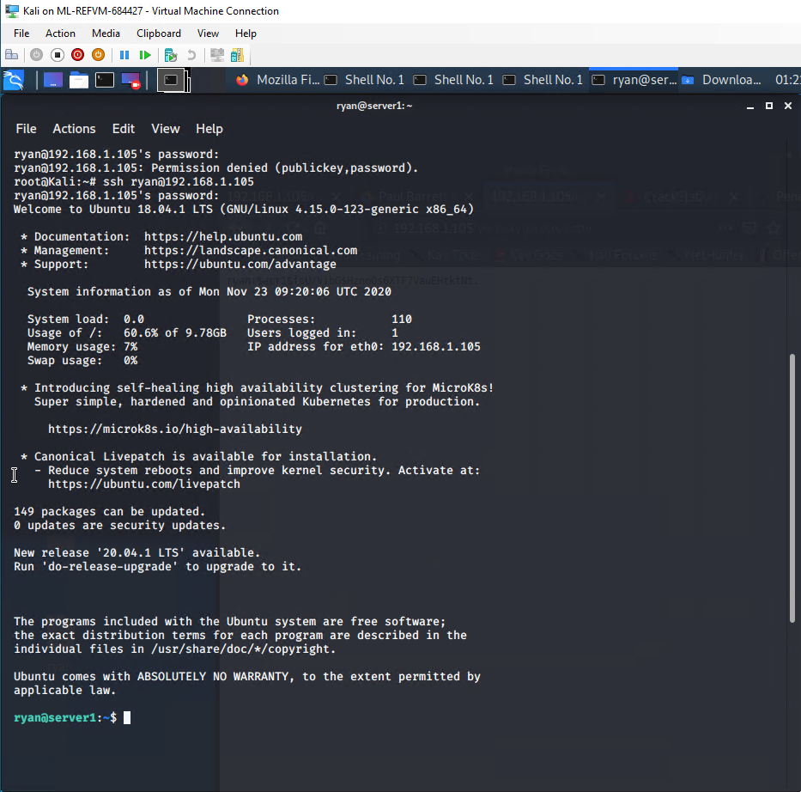

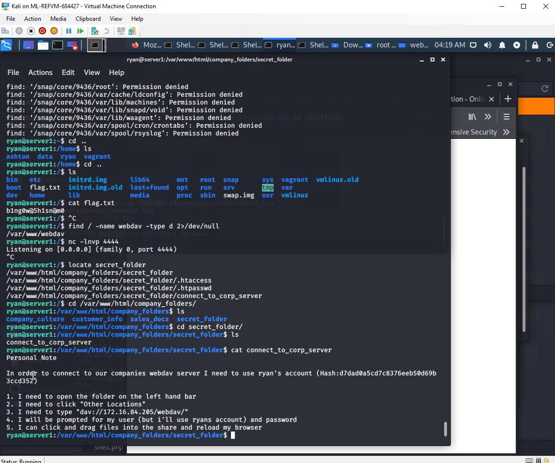

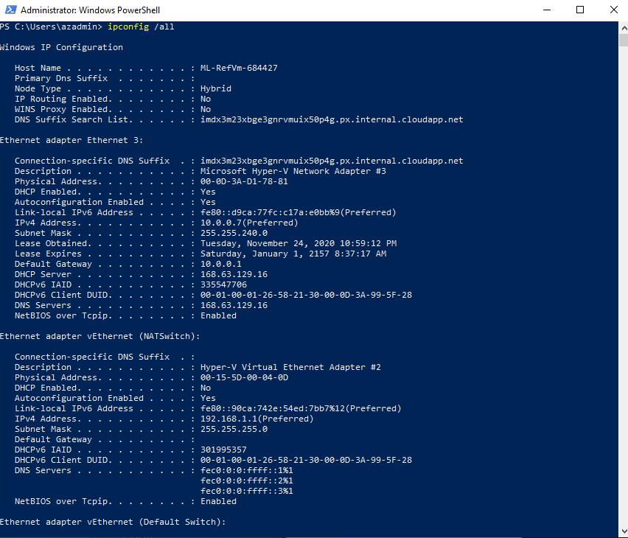

**Kibana**

I used Kibana to analyze logs

References

* [https://nvd.nist.gov/vuln/detail/](https://nvd.nist.gov/vuln/detail/CVE-2019-6579)
* <https://www.offensive-security.com/metasploit-unleashed/file-inclusion-vulnerabilities/>
* <https://cwe.mitre.org/data/definitions/548.html#:~:text=A%20directory%20listing%20is%20inappropriately,potentially%20sensitive%20information%20to%20attackers.&text=A%20directory%20listing%20provides%20an,files%20are%20listed%20and%20accessible>.
* <https://null-byte.wonderhowto.com/how-to/exploit-webdav-server-get-shell-0204718/>
* https://www.netsparker.com/web-vulnerability-scanner/vulnerabilities/webdav-enabled/